**CSE 281: Data structures and Algorithms Lab**

**Lab Sheet 8**

**Circular Linked List and Doubly Linked List**

*Instructions: Write java programs and algorithms for question 1 and question 4.*

*Reference to java API is available at : http://192.168.0.48/javadocs/api/index.html.*

**---------------------------------------------------------------------------------------**

1. Implement the following in a circular linked list.
2. Insert at head.
3. Insert at tail.
4. Insert after a node.
5. Delete a node with given data item.
6. Delete a node at a given position.
7. Implement a procedure Sorted _insert() for circular linked list.

The function Sorted _insert() should insert a new value in a sorted Circular Linked List (CLL). For example, if the input CLL is following.

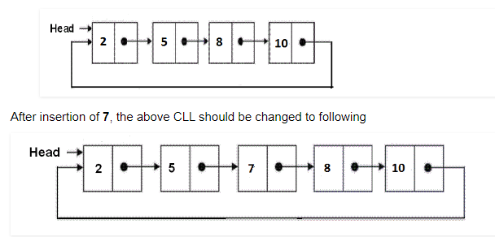

1. Implement a procedure to merge two circular linked lists.
2. Implement the following in a doubly linked list.
3. Insert at a position, after a given node.
4. Delete a node with given data.
5. Revers first k elements.